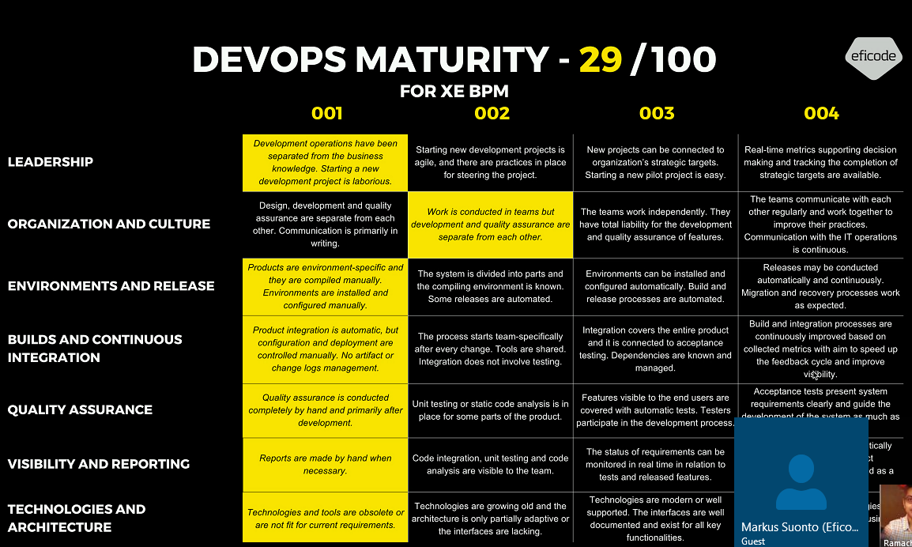

Business & Team are different – no will to involve the software development in the business

Task are sent to India to be implemented & its delivered back

It’s more separate

Last 1 year CRs are collected by Eficode – what are the releases – how much time / planned release & estimated release?

What has been really done?

Practices are in place.

Business analyst role to India to closely relate with business and development

Environment & release – you don’t have the full control of the env.

BPM Team to work with DRS / Arun for Builds & Continuous Integration

Visibility & Reporting: Reports made manually

Technology & Arch: NO CI in place

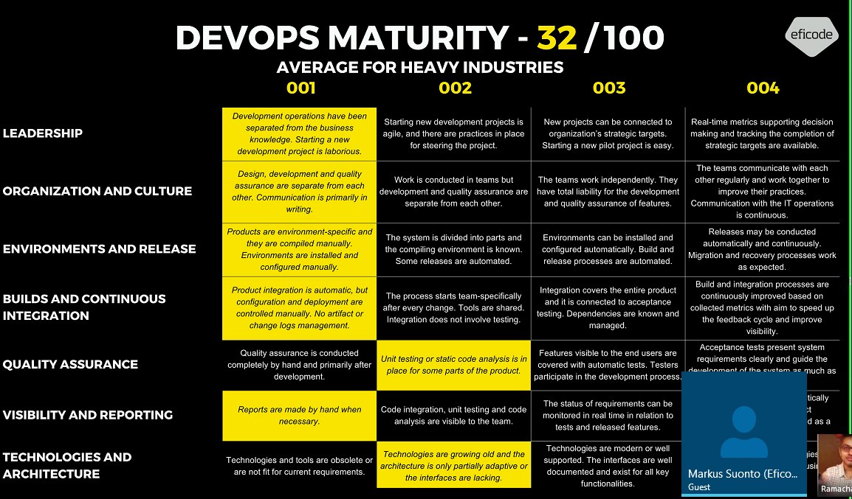

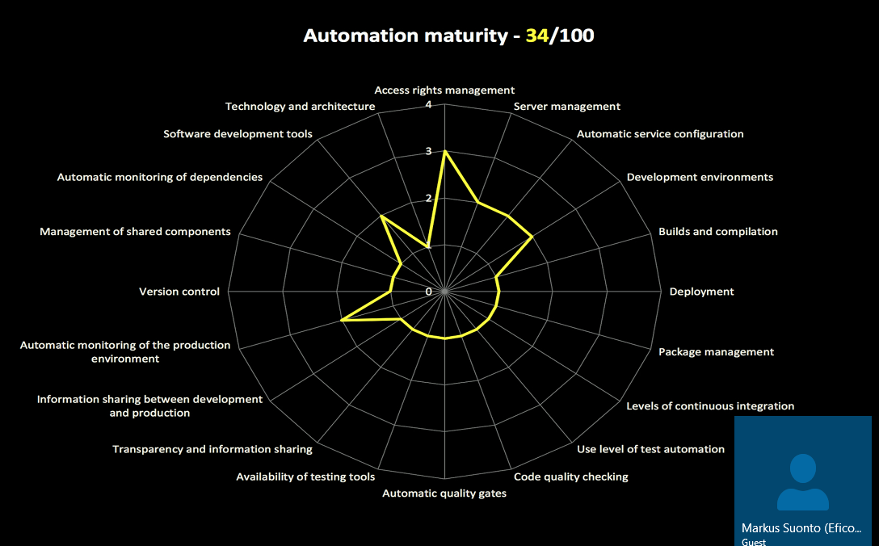

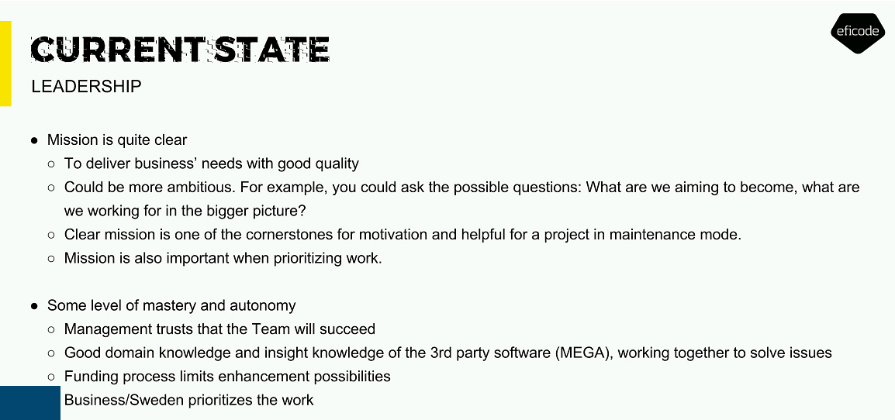

Need to try experiment

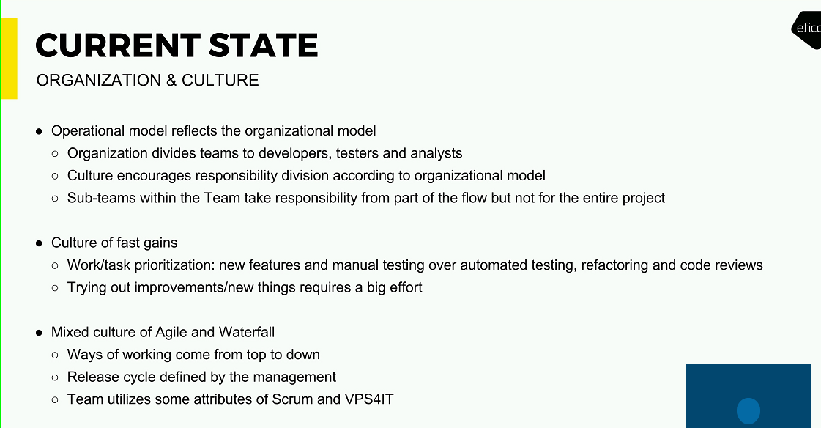

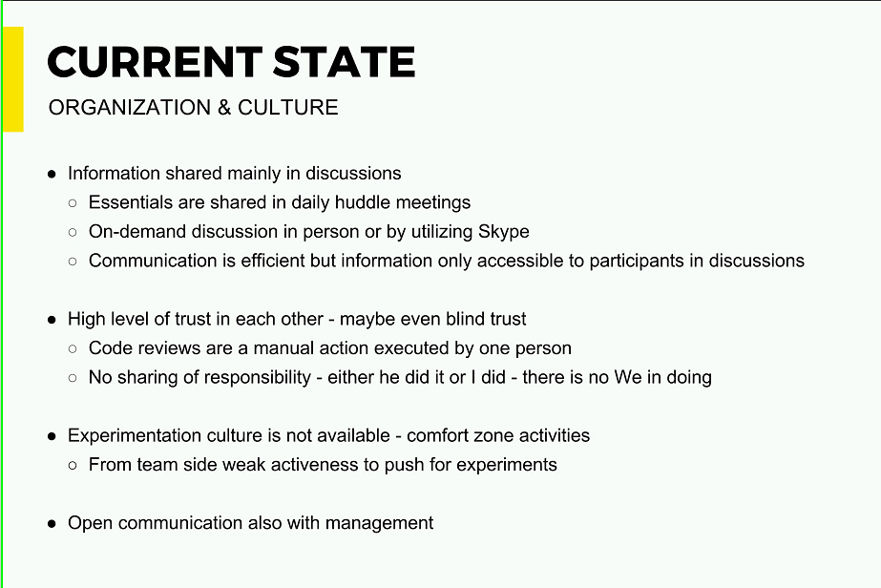

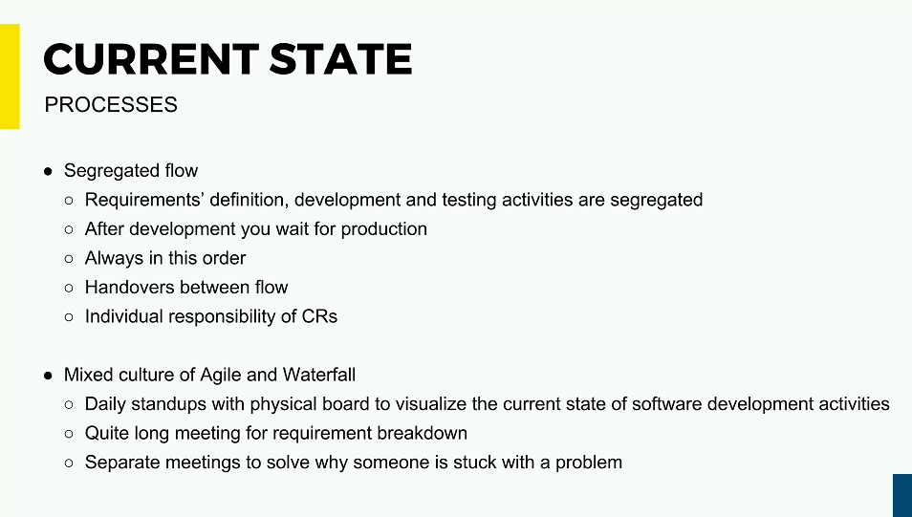

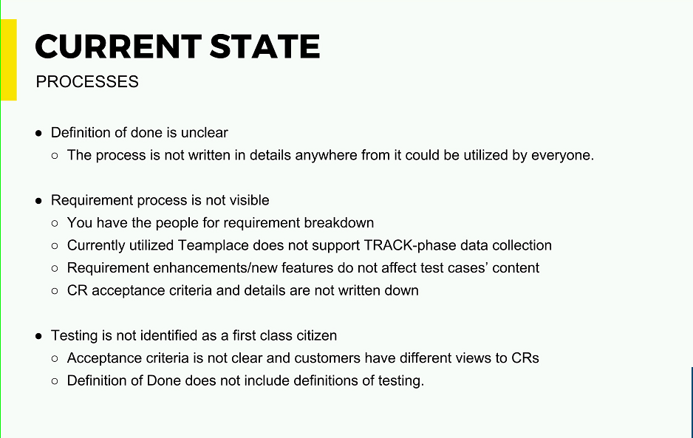

DOD: Not uniform

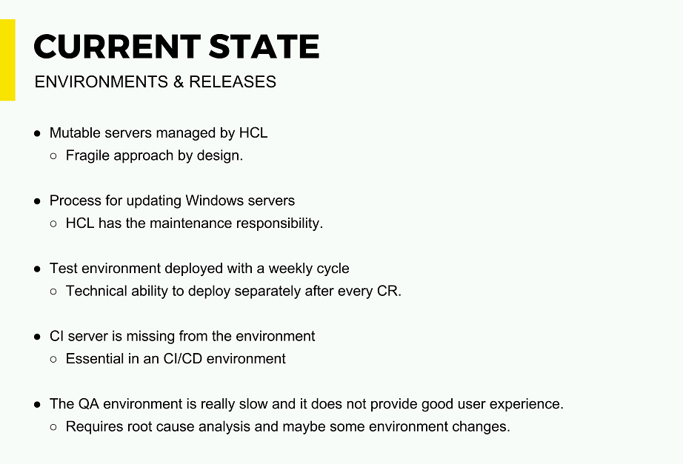

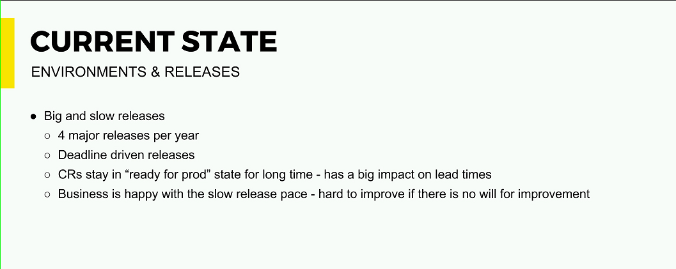

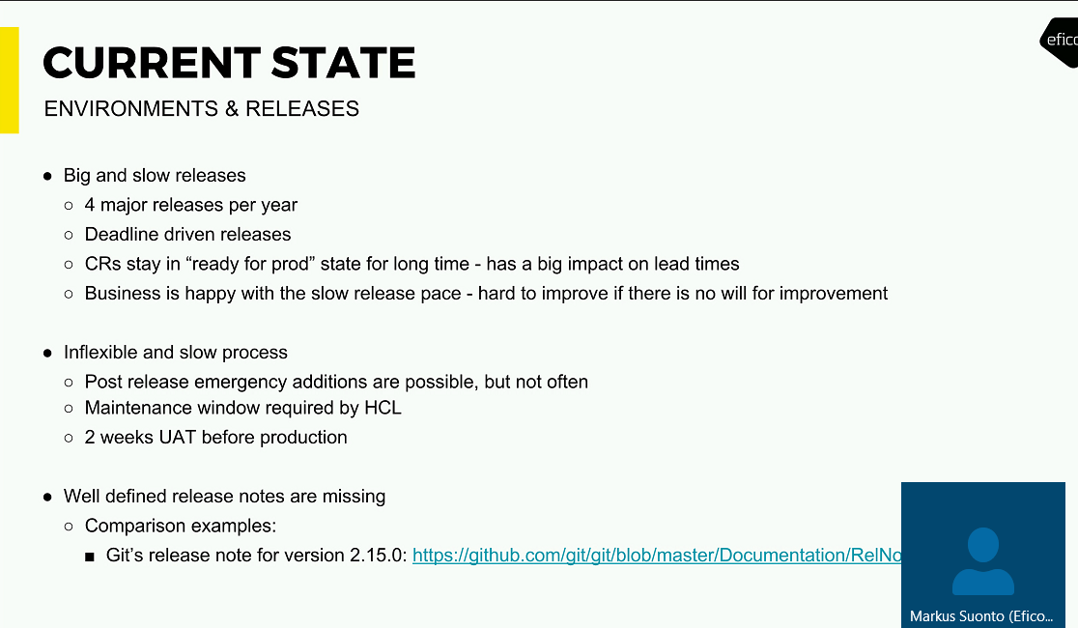

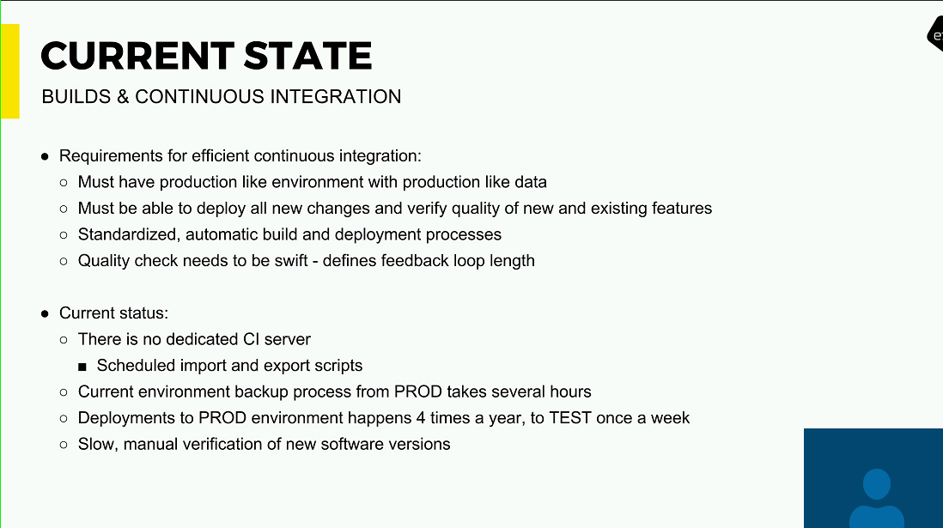

Production like environments but the performance are not similar

Verify the quality – automatically – Quality assurance

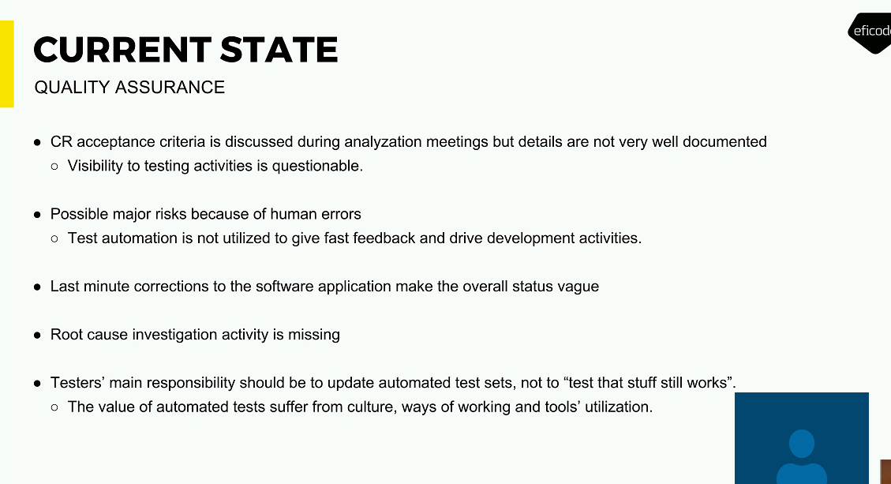

Testing done mostly after all the development is finished

Test cases are not versioned

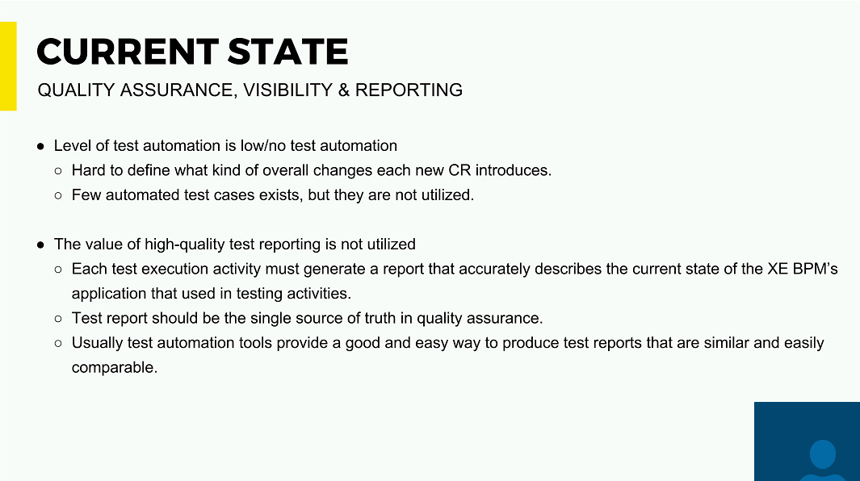

Automation of test case:

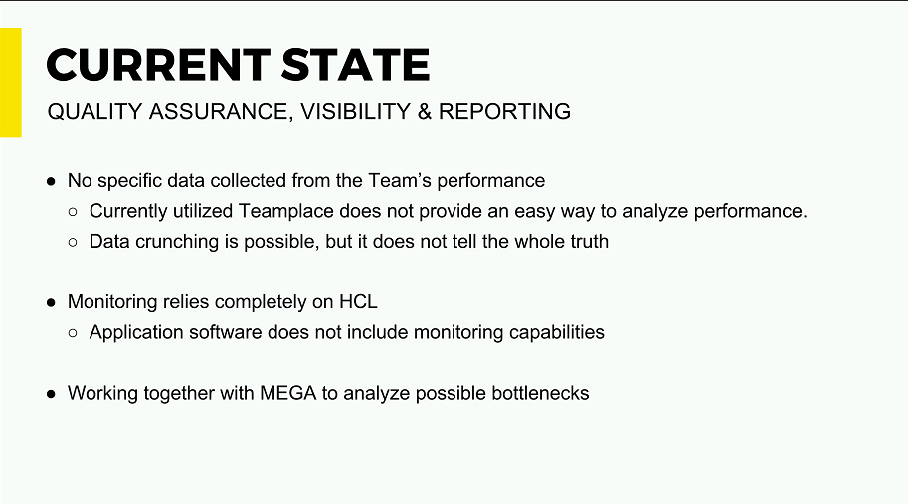

Monitoring tools : BPM team has no access to the tool

Mega: not much scope of improvement with Mega software

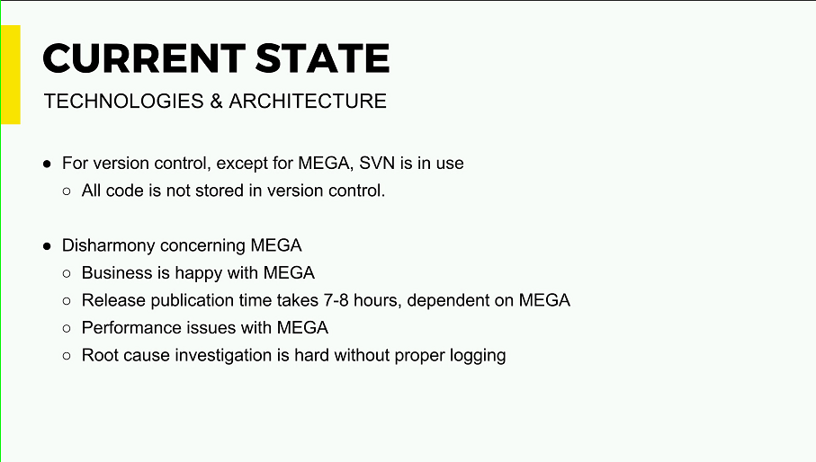

2 version control tool

Business is happy with Mega

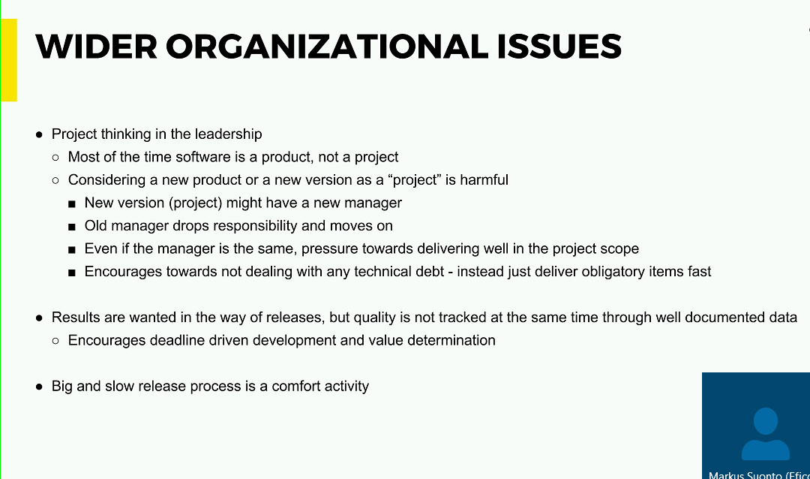

Release activity can be much faster

UAT is a bottleneck – as it takes a lot of time

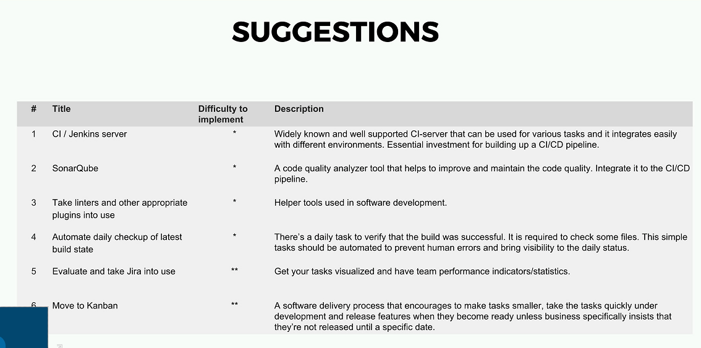

Linters – help you in the syntax in place in the development

4 – daily check up - Jenkins server – to see the logs on the daily builds

5 – Implementation of Jira

6 - Change request & deploy them but you are not doing them unless Business specific inform not to.

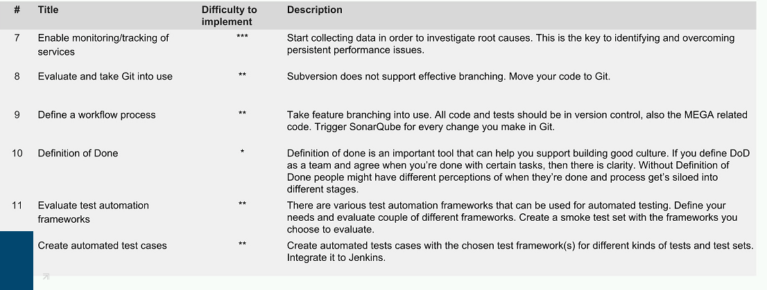

Point 5 – 7 connected – collect some data on the performance issue – convince HCL to get the access to the monitoring

8 – find out any way to have all the code

* Automatically upload all the code to mega
* Get all the code to the same version control

9 – no real workflow – how do you strategy – no proper branch.

10- DOD: it can support you to built more unified. Individually done & as a team you are done

11- Quality assurance – Automation on the test automation –

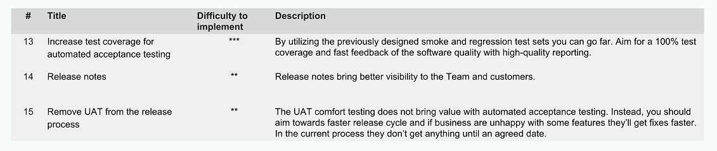

13 – 15 are related Technical quality of the software is good.

14 – Writing release note of what has been changed

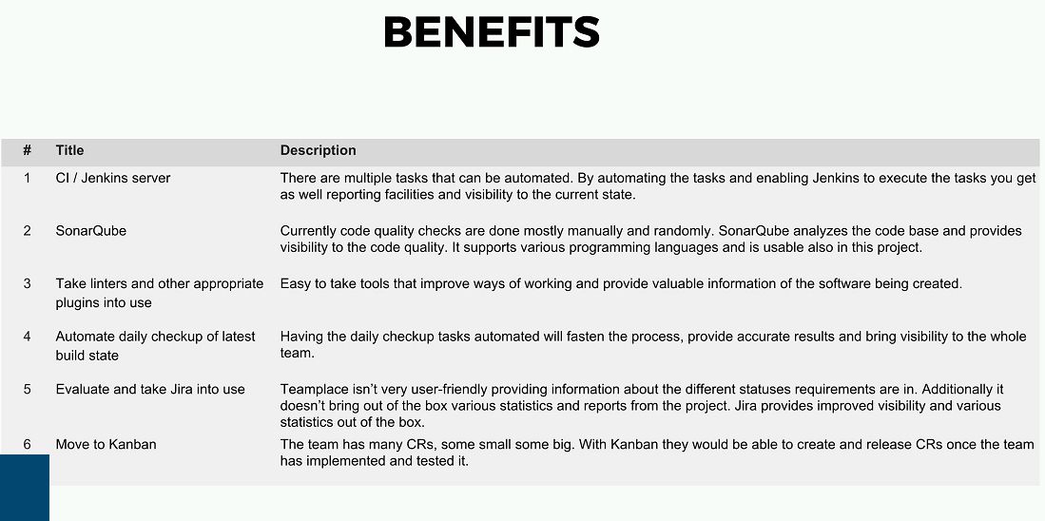

Linters should help you with syntax

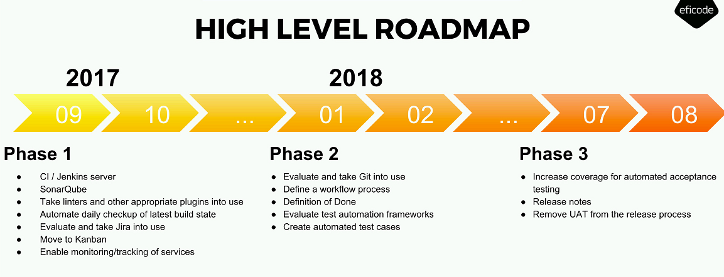

Proper workflow if you don’t have a good branching strategy